**Cloud Computing Definition**

**NIST Definition of Cloud Computing**

A good starting point for a definition of cloud computing is the definition issued by the U.S. National Institute of Standards and Technology (NIST) September, 2011. It starts with:

***Cloud computing*** *is a model for enabling ubiquitous, convenient, on-demand network access to a shared pool of configurable computing resources (e.g., networks, servers, storage, applications, and services) that can be rapidly provisioned and released with minimal management effort or service provider interaction. This cloud model is composed of five essential characteristics, three service models, and four deployment models.* (The NIST Definition of Cloud Computing, [SP800-145.pdf](http://csrc.nist.gov/publications/nistpubs/800-145/SP800-145.pdf))

Before getting to the essential characteristics, service models, and deployment models of the cloud model mentioned at the end of the definition, let's pause for a moment and consider this first part of the first sentence. It mentions a *shared pool of configurable computing resources*. This aspect of Cloud Computing is not new. In fact, it is fair to draw a direct line from [time-sharing](http://en.wikipedia.org/wiki/Time-sharing)—that was initiated in the late 1950s and saw significant growth in the 1960s and 1970s—to today's Cloud Computing. Adding to that, however, is the essential characteristic of Cloud Computing known as *elasticity*. The second part of the first sentence alludes to elasticity by stating there are *computing resources ... that can be rapidly provisioned and released with minimal management effort or service provider interaction*. (We'll get to *service provider* later.)

The end of the first sentence of the definition mentions a *service provider*. In Cloud Computing, the elastic computing resources are used to provide a service. It is unclear how rigorous we should view the term *service* in this definition. Nevertheless, Cloud Computing is very much involved with the software engineering term *service*. A service is the endpoint of a connection. Also, a service has some type of underlying computer system that supports the connection offered (in this case the elastic computing resources).

* [Web Services and Cloud Computing](http://www.service-architecture.com/articles/cloud-computing/web_services_and_cloud_computing.html)
* [Service-Oriented Architecture (SOA) and Cloud Computing](http://www.service-architecture.com/articles/cloud-computing/service-oriented_architecture_soa_and_cloud_computing.html)

The NIST Definition of Cloud Computing lists **five essential characteristics** of Cloud Computing. It is reasonable to assume that missing any one of these essential characteristics means a service or computing capability cannot be considered as Cloud Computing.

1. ***On-demand self-service.*** *A consumer can unilaterally provision computing capabilities, such as server time and network storage, as needed automatically without requiring human interaction with each service provider.*
2. ***Broad network access.*** *Capabilities are available over the network and accessed through standard mechanisms that promote use by heterogeneous thin or thick client platforms (e.g., mobile phones, tablets, laptops, and workstations).*
3. ***Resource pooling.*** *The provider's computing resources are pooled to serve multiple consumers using a* ***multi-tenant model****, with different physical and virtual resources dynamically assigned and reassigned according to consumer demand. There is a sense of location independence in that the customer generally has no control or knowledge over the exact location of the provided resources but may be able to specify location at a higher level of abstraction (e.g., country, state, or datacenter). Examples of resources include storage, processing, memory, and network bandwidth.*
4. ***Rapid elasticity.*** *Capabilities can be elastically provisioned and released, in some cases automatically, to scale rapidly outward and inward commensurate with demand. To the consumer, the capabilities available for provisioning often appear to be unlimited and can be appropriated in any quantity at any time.*
5. ***Measured service.*** *Cloud systems automatically control and optimize resource use by leveraging a metering capability at some level of abstraction appropriate to the type of service (e.g., storage, processing, bandwidth, and active user accounts). Typically this is done on a pay-per-use or charge-per-use basis. Resource usage can be monitored, controlled, and reported, providing transparency for both the provider and consumer of the utilized service.*

So, Cloud Computing is measured, on-demand, elastic computing using pooled resources, usually on the Internet.

Next, the NIST Definition of Cloud Computing list **three service models**:

1. ***Software as a Service (SaaS).*** *1.The capability provided to the consumer is to use the provider's applications running on a cloud infrastructure 2. The applications are accessible from various client devices through either a thin client interface, such as a web browser (e.g., web-based email), or a program interface. 3.The consumer does not manage or control the underlying cloud infrastructure including network, servers, operating systems, storage, or even individual application capabilities, with the possible exception of limited user-specific application configuration settings.* More on [Software as a Service (SaaS)](http://www.service-architecture.com/articles/cloud-computing/software_as_a_service_saas.html)
2. ***Platform as a Service (PaaS).*** *The capability provided to the consumer is to deploy onto the cloud infrastructure consumer-created or acquired applications created using programming languages, libraries, services, and tools supported by the provider. The consumer does not manage or control the underlying cloud infrastructure including network, servers, operating systems, or storage, but has control over the deployed applications and possibly configuration settings for the application-hosting environment.* More on [Platform as a Service (PaaS)](http://www.service-architecture.com/articles/cloud-computing/platform_as_a_service_paas.html).
3. ***Infrastructure as a Service (IaaS).*** *The capability provided to the consumer is to provision processing, storage, networks, and other fundamental computing resources where the consumer is able to deploy and run arbitrary software, which can include operating systems and applications. The consumer does not manage or control the underlying cloud infrastructure but has control over operating systems, storage, and deployed applications; and possibly limited control of select networking components (e.g., host firewalls).* More on [Infrastructure as a Service (IaaS)](http://www.service-architecture.com/articles/cloud-computing/infrastructure_as_a_service_iaas.html).

Although it is not part of the NIST Definition of Cloud Computing, Network as a Service (NaaS) is sometimes factored out of IaaS. See [Network as a Service (NaaS)](http://www.service-architecture.com/articles/cloud-computing/network_as_a_service_naas.html).

These service models need illustrations an further discussion to make them easier to understand. You can find such illustrations and further discussion of these service models in [Categories of Cloud Providers](http://www.service-architecture.com/articles/cloud-computing/cloud_computing_categories.html).

Finally, the NIST Definition of Cloud Computing **lists four deployment models**:

1. ***Private cloud.*** *The cloud infrastructure is provisioned for exclusive use by a single organization comprising multiple consumers (e.g., business units). It may be owned, managed, and operated by the organization, a third party, or some combination of them, and it may exist on or off premises.* More on [Private Clouds](http://www.service-architecture.com/articles/cloud-computing/private_cloud.html).
2. ***Community cloud.*** *The cloud infrastructure is provisioned for exclusive use by a specific community of consumers from organizations that have shared concerns (e.g., mission, security requirements, policy, and compliance considerations). It may be owned, managed, and operated by one or more of the organizations in the community, a third party, or some combination of them, and it may exist on or off premises.* More on [Community Clouds](http://www.service-architecture.com/articles/cloud-computing/community_cloud.html).
3. ***Public cloud.*** *The cloud infrastructure is provisioned for open use by the general public. It may be owned, managed, and operated by a business, academic, or government organization, or some combination of them. It exists on the premises of the cloud provider.* More on [Public Clouds](http://www.service-architecture.com/articles/cloud-computing/public_cloud.html).
4. ***Hybrid cloud.*** *The cloud infrastructure is a composition of two or more distinct cloud infrastructures (private, community, or public) that remain unique entities, but are bound together by standardized or proprietary technology that enables data and application portability (e.g.,* [*cloud bursting*](http://www.service-architecture.com/articles/cloud-computing/cloud_bursting.html) *for load balancing between clouds).* More on [Hybrid Clouds](http://www.service-architecture.com/articles/cloud-computing/hybrid_cloud.html).

Like the service models, these deployment models need illustrations and further discussion. You can find such illustrations and further discussion of these deployment models in [Types of Clouds in Cloud Computing](http://www.service-architecture.com/articles/cloud-computing/types_of_clouds_in_cloud_computing.html).

**Cloud Computing Commentary**

The "cloud" in Cloud Computing likely came from the common use of a cloud symbol for the Internet that, in turn, was derived from the use of cloud symbols commonly used in general telecommunication diagrams pre-dating the Internet.

The term *Cloud Computing* can be sometimes useful and sometimes misleading because people seem to think they understand the meaning of the term even when they don't. To illustrate the use of the term, someone I know told me of a meeting where he was explaining [virtual private servers](http://en.wikipedia.org/wiki/Virtual_private_server) to group of non-technical people. The group was having trouble understanding some of the most basic concepts. He finally gave up and told the group that the servers were "in the Cloud." At that point, everyone in the group brightened and said they now understood. But they really didn't understand. They just thought they did because they thought they understood term *Cloud Computing*. But, in all likelihood, they did not understand that either. The presenter in this story was not trying to mislead people when he resorted to using "the Cloud" to help explain what he was discussing. Nevertheless, you may find intentional attempts to mislead if "Cloud" is added to products and services when those products and services really do not involve Cloud Computing. The term for this is[*cloud washing*](http://www.service-architecture.com/articles/cloud-computing/cloud_washing.html)[.](http://searchcloudstorage.techtarget.com/definition/cloud-washing)

# Software as a Service (SaaS)

## Software as a Service (SaaS) Discussion

Software as a Service (SaaS) is what most people mean when they say "the Cloud." SaaS provides a complete software solution. This software could be email management, calendaring, enterprise resource planning (ERP), customer relationship management (CRM), documentation management, and so on. The easiest way to think about SaaS is that it is some type of standard software package that can be used on demand and is paid for by subscription, by use, by advertising, or by sharing information (such as email addresses) of users.

Most [Application Program Interfaces (APIs)](https://www.service-architecture.com/articles/web-services/application_program_interfaces_apis.html) are associated with SaaS Cloud Providers.

## Software as a Service (SaaS) Advantages

### Advantages Unique to Software as a Service (SaaS)

* More than typical packaged software, using a SaaS provider will require you or your organization to use a "vanilla" version of the software. Minimal customization is typically offered. Sometimes being forced to use a "vanilla" version is helpful. (This can also be a disadvantage.)

### Advantages Shared With Platform as a Service (PaaS) and Infrastructure as a Service (IaaS)

* Various pricing models may allow paying only for what you use. This, for example, can allow an individual or a small organization to use sophisticated software that they could not afford if it was installed on an internal, dedicated server.
* SaaS Cloud Providers often take into account multiple platforms: mobile, browser, and so on. If you or your organization want software that can be accessed from multiple platforms, this might be an easy way to make that happen. As part of this, SaaS Cloud Providers may also provide apps for mobile devices.
* If you have events such as high seasonal sales activity, then the [elasticity of the Cloud](https://www.service-architecture.com/articles/cloud-computing/cloud_computing_definition.html#elasticity) with SaaS might provide an opportunity.
* The SaaS Cloud Provider may provide better security than your existing software (security—or inadequate security—can also be a disadvantage). Better security may come in part because it is critical for the SaaS Cloud Provider and is part of their main business. In-house security, on the other hand, is not usually an individual's or a organization's main business and, therefore, may not be as good as that offered by the SaaS Cloud Provider.
* No need to manage the introduction of new releases of the software. This is handled by the SaaS Cloud Provider.
* No need to provision servers. This is handled by the SaaS Cloud Provider.
* No need to manage the underlying data center. This is handled by the SaaS Cloud Provider.
* Usually, there is no need to manage backups. This is handled by the SaaS Cloud Provider.
* If the SaaS Cloud Provider supports failover should the software (for example, the database management software) or the data center become unavailable, that failover is a concern of the SaaS Cloud Provider and you do not need to plan for it.

## Software as a Service (SaaS) Disadvantages

### Disadvantages Unique to Software as a Service (SaaS)

* More than typical packaged software, using a SaaS Cloud Provider will require your or your organization to use a "vanilla" version of the software. Minimal customization is typically offered. (This is also an advantage.)

### Advantages Shared With Platform as a Service (PaaS) and Infrastructure as a Service (IaaS)

* There may be legal reasons that preclude the use of off-premise or out-of-country data storage.
* Security features of the SaaS Cloud Provider may not adequate for your needs.
* If you have a need for high-speed interaction between your internal software or software in another Cloud and the SaaS Cloud Provider, relying on an Internet connection may not provide the speed that you need.

Software as a Service (SaaS) Variations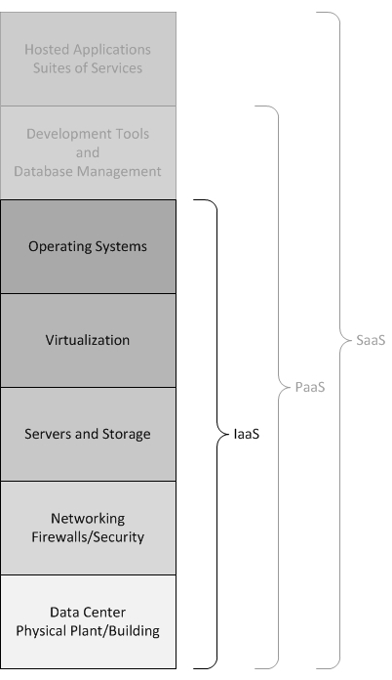

* [Communications as a Service (CaaS)](https://www.service-architecture.com/articles/cloud-computing/communications_as_a_service_caas.html)

# Platform as a Service (PaaS)

## Platform as a Service (PaaS) Discussion

Platform as a Service (PaaS) is the next step down from Software as a Service (SaaS) in the Cloud Computing Stack. Instead of ready-made applications or services, PaaS provides the platform for developing such applications and services. Here you find various development tools and such things as [database management systems,](https://www.service-architecture.com/articles/database/index.html) [enterprise service buses (ESBs),](https://www.service-architecture.com/articles/web-services/enterprise_service_bus_esb.html) [application servers,](https://www.service-architecture.com/articles/application-servers/index.html) [business intelligence (BI)](http://en.wikipedia.org/wiki/Business_intelligence)/[business analytics](http://en.wikipedia.org/wiki/Business_analytics), and so on that could be used to support the applications and services developed.

## Platform as a Service (PaaS) Advantages

### Advantages Unique to Platform as a Service (PaaS)

* You or your organization are responsible for the
* versioning/upgrades of software developed (this is also a disadvantage).
* Advantages Shared with Infrastructure as a Service (IaaS)
* The maintenance and upgrades of tools, database systems, etc. and the underlying infrastructure is the responsibility of the PaaS Cloud Provider.
* Various pricing models may allow paying only for what you use. This, for example, can allow an individual or a small organization to use sophisticated development software that they could not afford if it was installed on an internal, dedicated server.
* Some PaaS Providers provide development options for multiple platforms: mobile, browser, and so on. If you or your organization want to develop software that can be accessed from multiple platforms, this might be an easy way to make that happen.
* If you have events such as high seasonal sales activity, then the [elasticity of the Cloud](https://www.service-architecture.com/articles/cloud-computing/cloud_computing_definition.html#elasticiy) with PaaS might provide an opportunity.
* The PaaS Cloud Provider may provide better security than your existing software (security—or inadequate security—can also be a disadvantage). Better security may come in part because it is critical for the PaaS Cloud Provider and is part of their main business. In-house security, on the other hand, is not usually an individual's or a organization's main business and, therefore, may not be as good as that offered by the PaaS Cloud Provider.
* No need to manage the introduction of new releases of the development or underlying software. This is handled by the PaaS Cloud Provider.
* No need to provision servers. This is handled by the PaaS Cloud Provider.
* No need to manage the underlying data center. This is handled by the PaaS Cloud Provider.
* Usually, there is no need to manage backups. This is handled by the PaaS Cloud Provider.
* If the PaaS Cloud Provider supports failover should the software (for example, the database management software) or the data center become unavailable, that failover is a concern of the PaaS Cloud Provider and you do not need to plan for it.

## Platform as a Service (PaaS) Disadvantages

### Disadvantages Unique to Platform as a Service (PaaS)

* You or your organization are responsible for the versioning/upgrades of software developed (this is also an advantage).

### Disadvantages Shared With Infrastructure as a Service (IaaS)

* When it is mandatory that the underlying hardware be of a specific type or the underlying software be modified to support the deployed application.
* There may be legal reasons that preclude the use of off-premise or out-of-country data storage.
* Security features of the PaaS Cloud Provider may not adequate for your needs.
* If you have a need for high-speed interaction between your internal software or software in another Cloud and the PaaS Cloud Provider, relying on an Internet connection may not provide the speed that you need.

## Platform as a Service (PaaS) Variations

# Infrastructure as a Service (IaaS)

## Infrastructure as a Service (IaaS) Discussion

Infrastructure as a Service (IaaS) is the next step down from Platform as a Service (PaaS) and two steps down from Software as a Service (SaaS) in the Cloud Computing Stack. Instead of ready-made applications or services, development tools, databases, etc., IaaS provides the underlying operating systems, security, networking, and servers for developing such applications, services, and for deploying development tools, databases, etc.

## Infrastructure as a Service (IaaS) Advantages

* You or your organization are responsible for the versioning/upgrades of software developed (this is also a disadvantage).
* The maintenance and upgrades of tools, database systems, etc. and the underlying infrastructure is your responsibility or the responsibility of your organization (this is also a disadvantage).
* Various pricing models may allow paying only for what you use. This, for example, can allow an individual or a small organization to use sophisticated development software that they could not afford if it was installed on an internal, dedicated server.
* Some IaaS Providers provide development options for multiple platforms: mobile, browser, and so on. If you or your organization want to develop software that can be accessed from multiple platforms, this might be an easy way to make that happen.
* If you have events such as high seasonal sales activity, then the [elasticity of the Cloud](https://www.service-architecture.com/articles/cloud-computing/cloud_computing_definition.html#elasticity) with IaaS might provide an opportunity.
* The IaaS Cloud Provider may provide better security than your existing software (security—or inadequate security—can also be a disadvantage). Better security may come in part because it is critical for the IaaS Cloud Provider and is part of their main business. In-house security, on the other hand, is not usually an individual's or a organization's main business and, therefore, may not be as good as that offered by the IaaS Cloud Provider.
* No need to manage the introduction of new releases of the development or underlying software. This is handled by the IaaS Cloud Provider.
* No need to manage the underlying data center. This is handled by the IaaS Cloud Provider.
* Usually, there is no need to manage backups. This is handled by the IaaS Cloud Provider.
* If the IaaS Cloud Provider supports failover should the software (for example, the database management software) or the data center become unavailable, that failover is a concern of the IaaS Cloud Provider and you do not need to plan for it.

## Infrastructure as a Service (IaaS) Disadvantages

* You or your organization are responsible for the versioning/upgrades of software developed (this is also an advantage).
* The maintenance and upgrades of tools, database systems, etc. and the underlying infrastructure is your responsibility or the responsibility of your organization (this is also an advantage).
* When it is mandatory that the underlying hardware be of a specific type or the underlying software be modified to support the deployed application.
* There may be legal reasons that preclude the use of off-premise or out-of-country data storage.
* Security features of the IaaS Cloud Provider may not adequate for your needs.
* If you have a need for high-speed interaction between your internal software or software in another Cloud and the IaaS Cloud Provider, relying on an Internet connection may not provide the speed that you need.

## Network as a Service (NaaS) Variations

Sometimes Network as a Service (NaaS) is factored out of IaaS. See [Network as a Service (NaaS)](https://www.service-architecture.com/articles/cloud-computing/network_as_a_service_naas.html).

Network as a Service (NaaS)

Network as a Service (NaaS) Discussion

Network as a Service (NaaS) is sometimes listed as a separate Cloud provider along with Infrastructure as a Service (IaaS), Platform as a Service (PaaS), and Software as a Service (SaaS). This factors out networking, firewalls, related security, etc. from IaaS as is shown in the figure below.

NaaS can include flexible and extended Virtual Private Network (VPN), bandwidth on demand, custom routing, multicast protocols, security firewall, intrusion detection and prevention, Wide Area Network (WAN), content monitoring and filtering, and antivirus. There is no standard specification as to what is included in NaaS. Implementations vary.

NaaS Variation Some implementations of Network as a Service (NaaS) are referred to as Telco as a Service (TaaS). 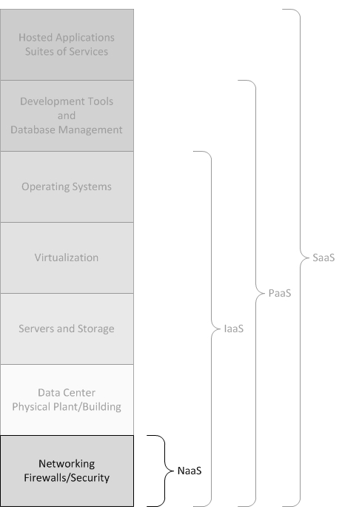

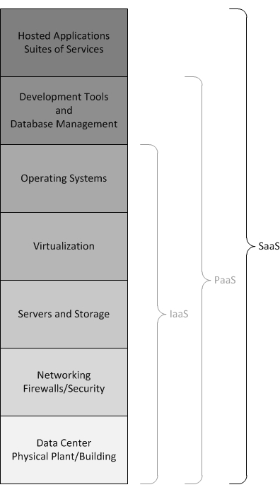

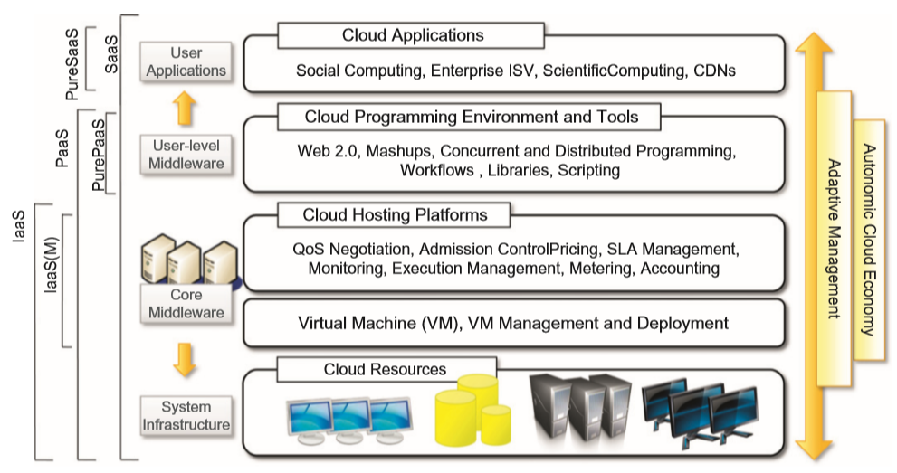

Cloud -Computing Architecture

Cloud Resources layer is implemented using Cloud Data Centre. Cloud Infrastructure can be heterogeneous nature—clusters, networked PCs can be used to build it.

Physical infrastructure is managed by core Middleware –to provide runtime environment for applications and to utilize resources at best.

At bottom of stack—Virtualization technologies are used to guarantee runtime environment customization, application isolation sandboxing and quality of service.

Hardware Virtualization is most commonly used in this layer.

Hypervisors manage pool of resources and expose distributed infrastructure as a collection of virtual machines. By using virtualization technology—to finely partition hardware resources such as CPU, Memory, and also virtualize specific devices, thus meeting requirements of users and applications.



The term *Web Services* refers to the technologies that allow for making connections. *Services* are what you connect together using Web Services. A service is the endpoint of a connection. Also, a service has some type of underlying computer system that supports the connection offered. The combination of services—internal and external to an organization—make up a *service-oriented architecture*.